- Open the Windows PowerShell console.
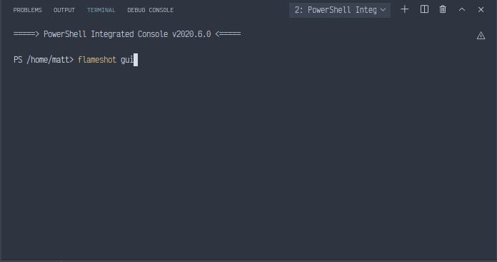
- Use the Get-Alias cmdlet to retrieve a listing of all the aliases defined on the computer for
Get-ChildItem. As shown here, use the -Definition parameter with the value of Get-ChildItem
to display the aliases for Get-ChildItem.
gal –definition Get-ChildItem
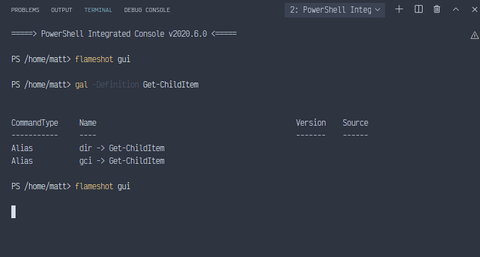
- Using the gci alias for the Get-ChildItem cmdlet, obtain a listing of files and folders contained
in the root directory. Type gci at the prompt.
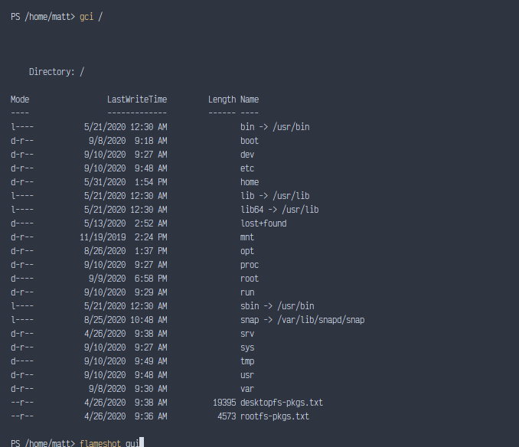
- To identify large files more quickly, pipeline the output to a Where-Object cmdlet, and specify
the -gt comparison operator with a value of 1000 to evaluate the length property. This is
shown here.
gci | Where length -gt 1000
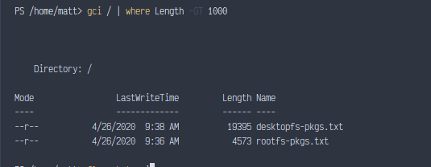
- To remove the data cluttering your Windows PowerShell window, use cls to clear the screen.
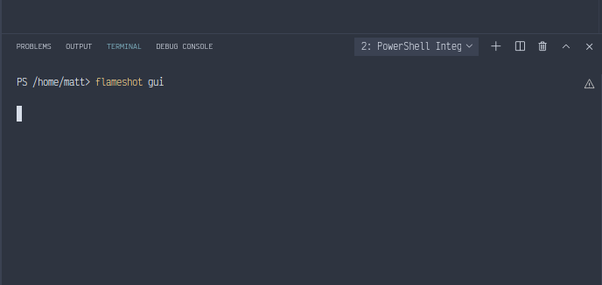
- Use the Get-Alias cmdlet to resolve the cmdlet to which the cls alias points. You can use the
gal alias to avoid typing Get-Alias if you want. This is shown here.
gal cls
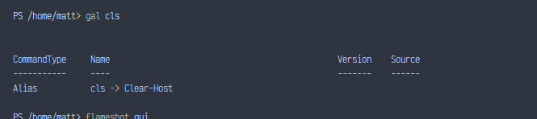
- Use the Get-Alias cmdlet to resolve the cmdlet to which the mred alias points. This is shown here.
gal mred
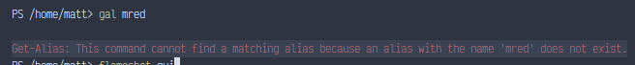
- Use the Clear-Host cmdlet to clear the screen. This is shown here.
Clear-host
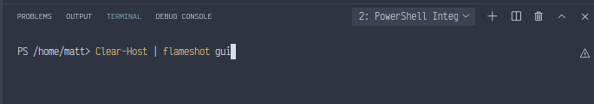
- Use the Get-Member cmdlet to retrieve a list of properties and methods from the
Get-ChildItem cmdlet. This is shown here.
Get-ChildItem | Get-Member -membertype property
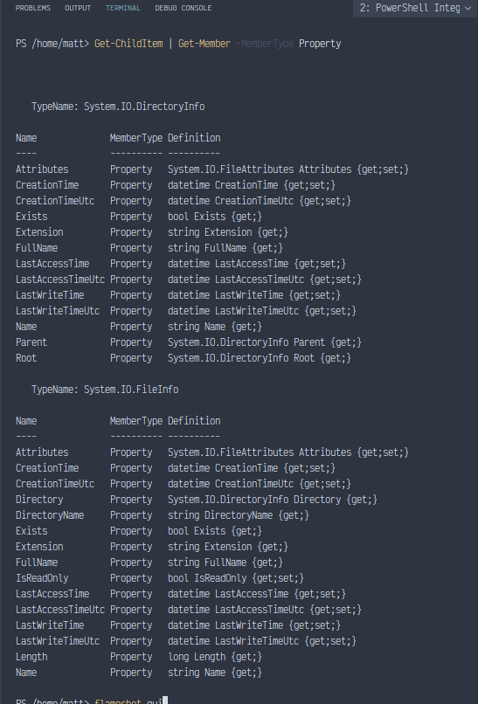
- The output from the preceding command is shown following. Examine the output, and iden-
tify a property that could be used with a Where-Object cmdlet to find the date when files were
modified.
TypeName: System.IO.DirectoryInfo
- Use the Where-Object cmdlet and include the LastWriteTime property, as follows.
Get-ChildItem | Where LastWriteTime
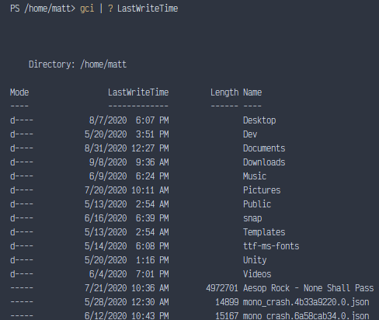
- Use the Up Arrow key in the Windows PowerShell console and bring the previous command
back up on the command line. Now specify the -gt comparison operator, and choose a recent
date from your previous list of files, so you can ensure that the query will return a result. My
command looks like the following.
Get-ChildItem | Where LastWriteTime -gt "12/25/2014"
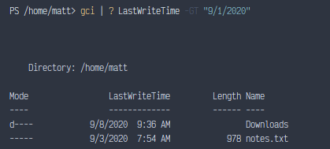
- Use the Up Arrow key and retrieve the previous command. Now direct the Get-ChildItem
cmdlet to a specific folder on your hard drive, such as C:\fso, which might have been created
in the step-by-step exercise in Chapter 1. You can, of course, use any folder that exists on your
machine. This command will look like the following.
Get-ChildItem "C:\fso"| Where LastWriteTime -gt "12/25/2014"
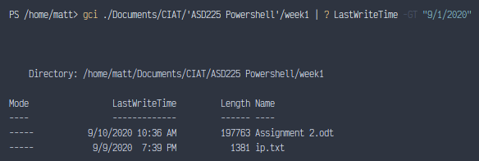
- Again, use the Up Arrow key to retrieve the previous command. Add the -Recurse switch
parameter to the Get-ChildItem cmdlet. If your previous folder was not nested, then you might
want to change to a different folder. You can, of course, use your Windows folder, which is
rather deeply nested. I used the Windows folder, and the command is shown here.
Get-ChildItem -Recurse C:\Windows | where lastwritetime -gt "12/12/14"
